THEVININ THEOREM

LAB # 10



Spring 2023
CSE103L Circuits & Systems-I Lab

Submitted by: TARIQ JAMIL
Registration No. : 22PWCSE2184
Class Section: A

“On my honor, as student of University of Engineering and Technology, I have neither given nor received unauthorized assistance on this academic work.”

Student Signature: ______________

Submitted to:
Dr. Muniba Ashfaq
Date: 13 June 2023

Department of Computer Systems Engineering
University of Engineering and Technology, Peshawar

TITLE:
Thevenin’s theorem.

Objective:
The objective of this lab is,
- To learn about thevenin theorem.
- To solve the problem related to thevenin theorem.
- To learn about Rth, Vth.
Definition:
Thevenin theorem states that any linear circuit containing several voltage sources and resistors can be simplified to a Thevenin equivalent circuit with a single voltage source and resistance connected in series with a load.
Problem
To find the value of Rth, Vth.
Diagram:
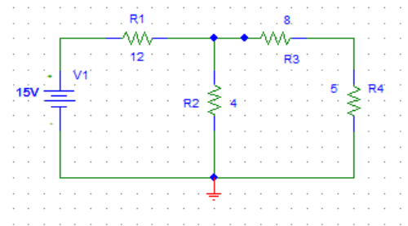
Solution:
We solve this problem in notebook. First we find Vth and then Rth.

Practical
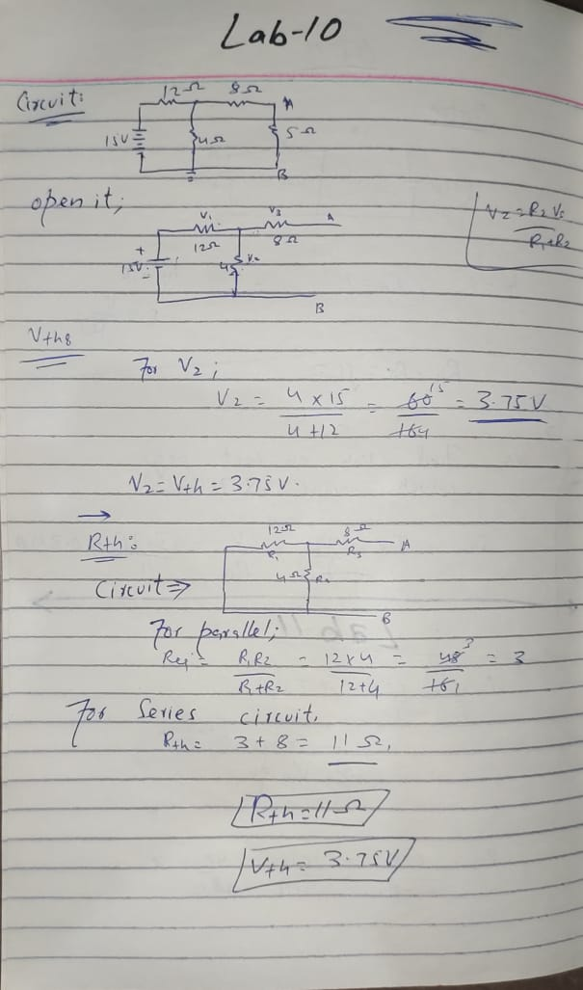

So we will get Vth = 3.75 V and Rth = 11ohm which is proved in notebook.
Difference between thevenin and Norton theorem:
Thevenin's Theorem utilises a voltage source, while Norton's Theorem uses a current source. Norton's Theorem employs a resistor set in parallel over the source, whereas Thevenin's Theorem utilises a resistor in series. From Thevenin's Theorem, Norton's Theorem can be easily derived.
Conclusion:
We solve the problem related to thevenin theorem.

LAB RUBRICS: (Circuits & Systems-I Lab)
Criteria & Point  Assigned | Outstanding  4 | Acceptable  3 | Considerable  2 | Below Expectations  1
Attendance and Attentiveness in  Lab  PLO10 | Attended in proper  Time and attentive in Lab | Attended in proper  Time but not attentive in Lab | Attended late but attentive in Lab | Attended late not attentive in Lab
Equipment / Instruments Selection and Operation  PLO1,  PLO2,  PLO3,  PLO5, | Right selection and operation of appropriate equipment and instruments to perform experiment. | Right selection of appropriate equipment and instruments to perform experiment but with minor issues in operation | Needs guidance for right selection of appropriate equipment and instruments to perform experiment and to overcome errors in operation | Cannot appropriately select and operate equipment and instruments to perform experiment.
Result or Output/ Completion of target  in Lab  PLO9, | 100% target has  been completed and well  formatted. | 75% target has been  completed and well formatted. | 50% target has  been completed but not well formatted. | None of the  outputs are  correct
Overall, Knowledge  PLO10, | Demonstrates excellent  knowledge of lab | Demonstrates good  knowledge of lab | Has partial idea about the Lab and  procedure followed | Has poor idea about the Lab and  procedure followed
Attention to Lab Report  PLO4, | Submission of Lab Report in Proper Time i.e. in next day of lab., with proper  documentation. | Submission of Lab Report in proper time but not with proper  documentation. | Late Submission  with proper  documentation. | Late Submission Very poor  documentation

